ADSD HW7 TinyDB ToDo

I use TinyDB CRUD both on local and pythonanywhere, to keep original peewee ORM working, I changed all TinyDB related request method.

Pythonanywhere:

Create:

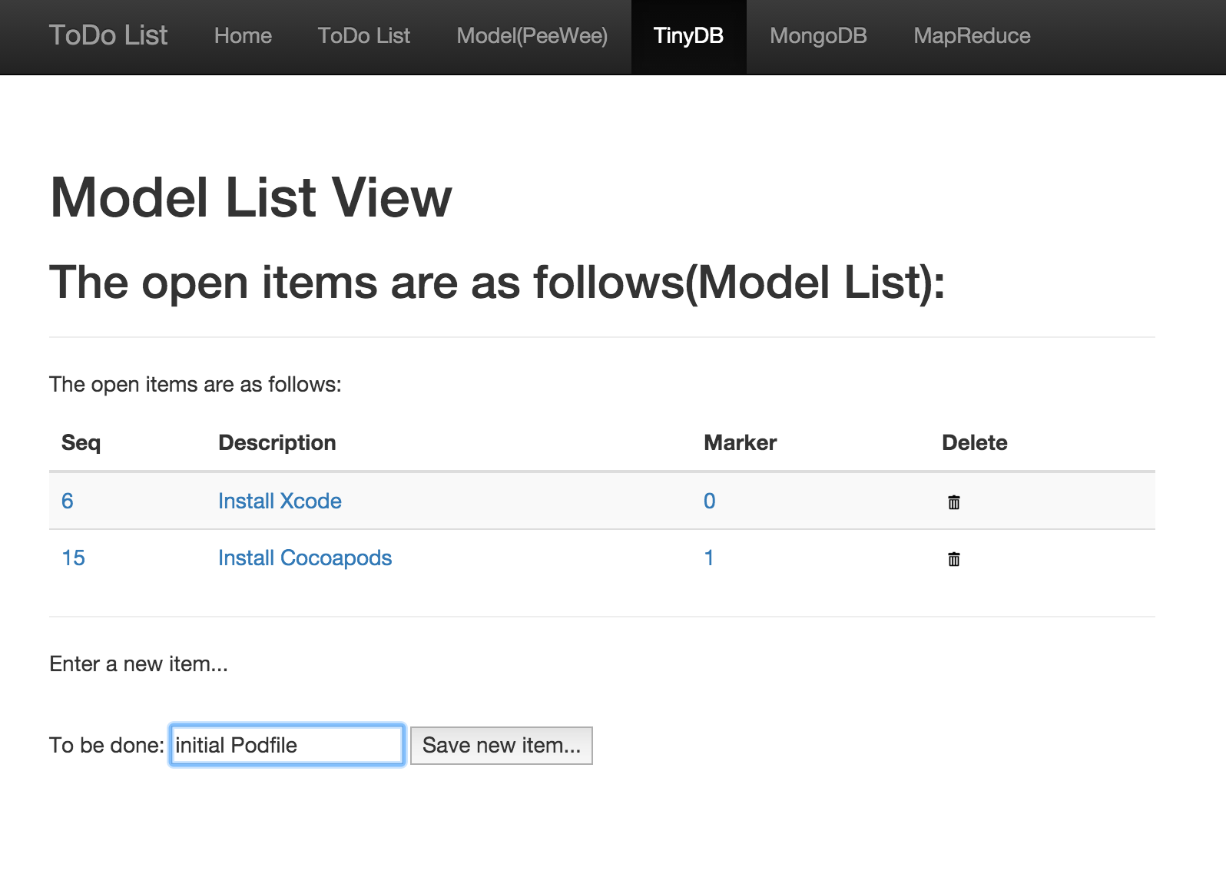

Update:

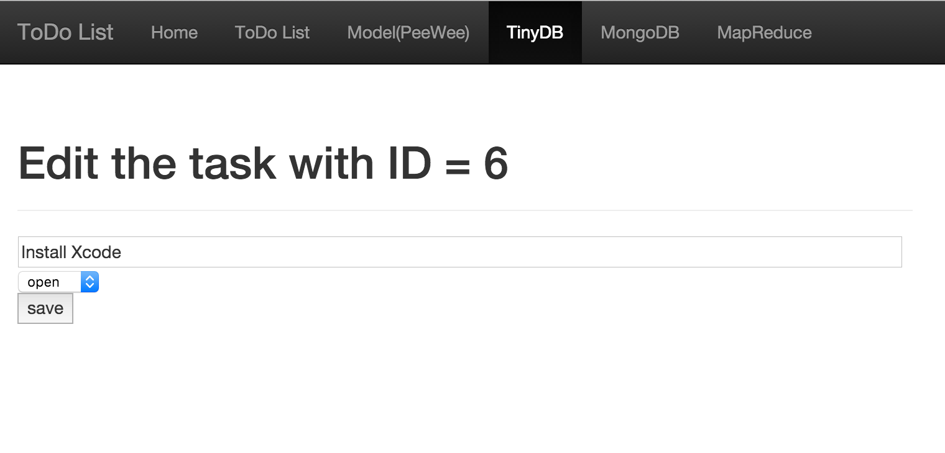

Read:

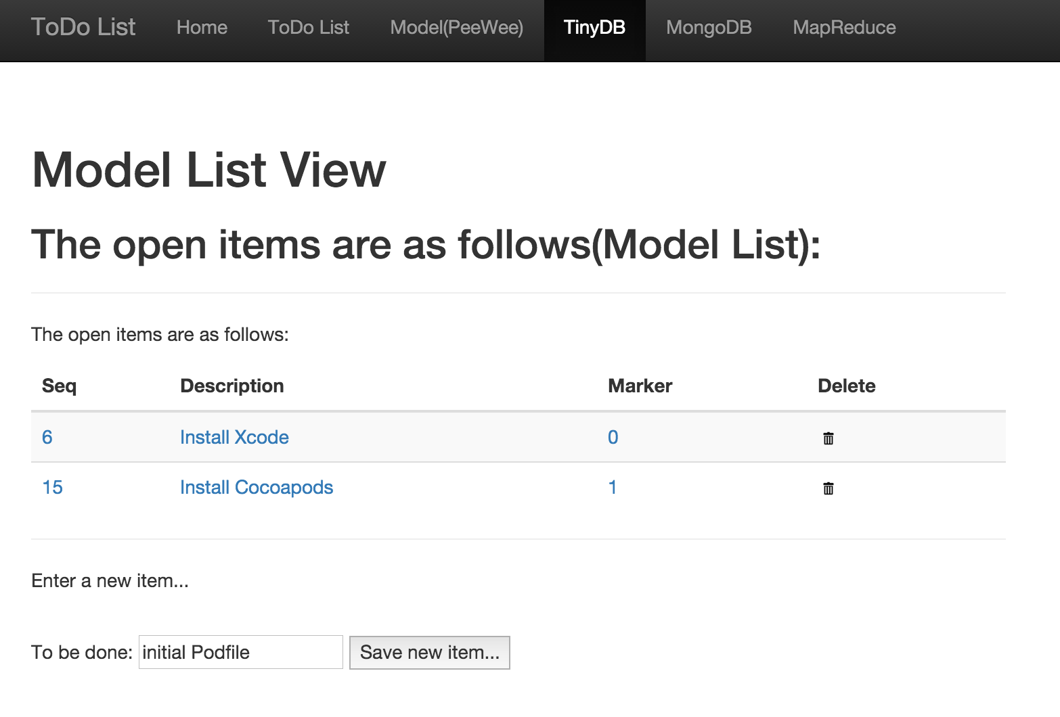

Delete:

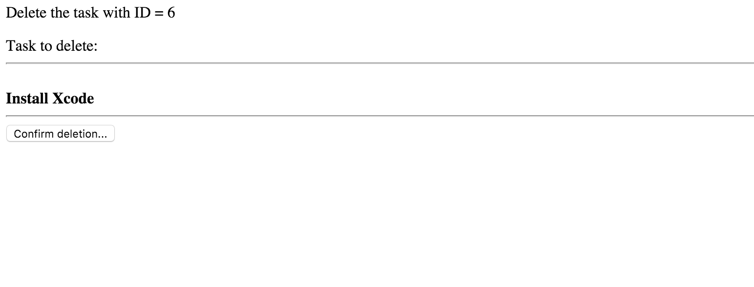

Code:

